Adventure Works Internet Sales

– Case Study Report

Student: Emily Chen  
Date of Submission: October 30, 2025、

# Executive Summary

This analysis summarizes Internet sales performance by year and country/region, explores income and demographic patterns, identifies the top‑grossing product (as a proxy for category), and assesses whether home ownership correlates with differences in purchasing. Insights inform recommendations for category focus, regional prioritization, and segmentation tests.

* Total Internet sales peak in 2013.
* Top‑selling product (proxy for category due to data limits): Mountain-200 Black, 46.
* Average unit price for that top product ≈ 2,215.27.
* Homeowners show higher average order value than non‑homeowners:

# Introduction: In order to guide its growth strategy, Adventure Works aims to gain a deeper understanding of online sales. The dataset includes 60 attributes that cover product attributes, order details, geographic information, and customer demographics. Four main questions were analyzed following variable standardization and data cleaning:

* What are the country/region and year-by-year Internet sales?
* What are the country-specific and gender-specific descriptive income statistics?
* What is the average price of the product category that sells the most?
* Does home ownership affect what people buy?

The English Product Name variable was utilized as a stand-in for the Product Category field since the dataset does not have one. Missing or distorted date entries were not included in the year-based aggregation, and all monetary values are treated as reported.

# Analysis

## Sales by Year and Country/Region

Figure 1 shows stacked yearly Internet sales by market; Table 1 reports the exact totals.

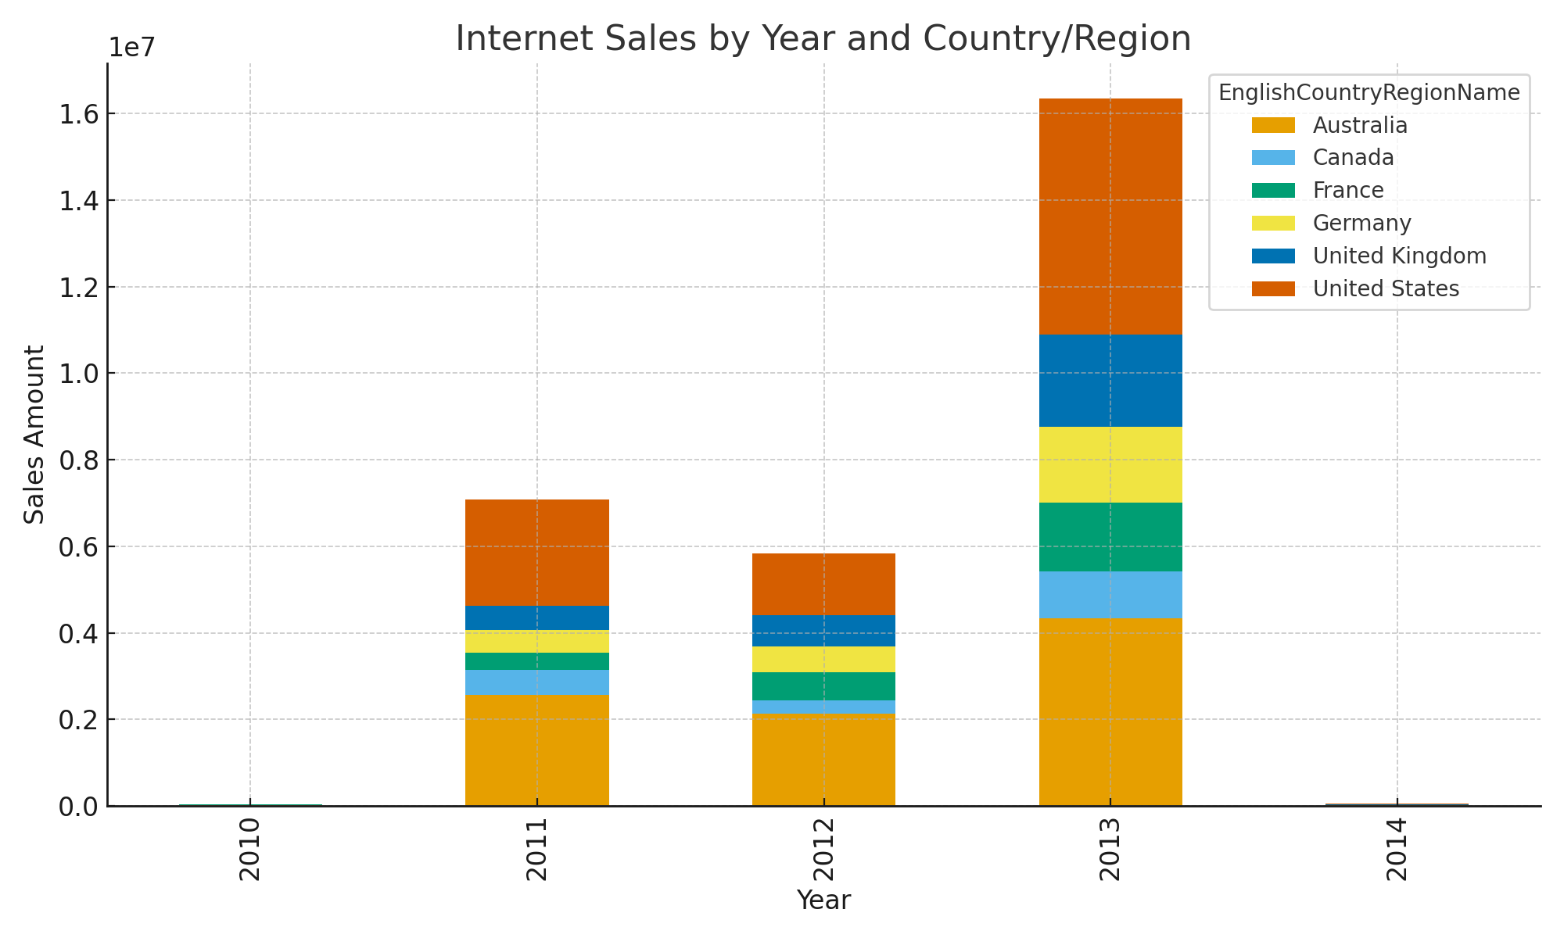

Figure 1. Internet Sales by Year and Country/Region.

|  |  |  |  |  |  |  |
| --- | --- | --- | --- | --- | --- | --- |
| Year | Australia | Canada | France | Germany | United Kingdom | United States |
| 2010 | 20,909.78 | 3,578.27 | 3,399.99 | 0.00 | 699.10 | 14,833.90 |
| 2011 | 2,563,732.25 | 571,571.80 | 410,845.33 | 520,500.16 | 550,591.22 | 2,458,285.17 |
| 2012 | 2,128,407.46 | 307,604.52 | 648,065.54 | 608,657.98 | 712,700.96 | 1,437,048.73 |
| 2013 | 4,339,443.38 | 1,085,632.65 | 1,578,511.80 | 1,761,876.36 | 2,124,007.29 | 5,462,078.86 |
| 2014 | 8,507.72 | 9,457.62 | 3,195.06 | 3,277.83 | 3,713.64 | 17,542.85 |

Table 1. Sales by Year & Country/Region.

## Income Summary by Country/Region and Gender

Count, mean, min, max, and std of Yearly Income grouped by country/region and gender.

|  |  |  |  |  |  |  |
| --- | --- | --- | --- | --- | --- | --- |
| EnglishCountryRegionName | Gender | count | mean | min | max | std |
| Australia | F | 6685 | 67,060.58 | 10,000.00 | 160,000.00 | 30,613.96 |
| Australia | M | 6660 | 65,412.91 | 10,000.00 | 170,000.00 | 32,550.78 |
| Canada | F | 3648 | 58,651.32 | 10,000.00 | 170,000.00 | 19,435.16 |
| Canada | M | 3972 | 61,460.22 | 10,000.00 | 170,000.00 | 22,702.85 |
| France | F | 2781 | 39,367.13 | 10,000.00 | 110,000.00 | 28,421.84 |
| France | M | 2777 | 39,805.55 | 10,000.00 | 110,000.00 | 28,665.66 |
| Germany | F | 2820 | 48,287.23 | 10,000.00 | 130,000.00 | 37,622.81 |
| Germany | M | 2805 | 46,730.84 | 10,000.00 | 130,000.00 | 37,487.62 |
| United Kingdom | F | 3401 | 56,518.67 | 10,000.00 | 170,000.00 | 51,130.69 |
| United Kingdom | M | 3505 | 55,771.75 | 10,000.00 | 170,000.00 | 50,963.71 |
| United States | F | 10682 | 64,766.90 | 10,000.00 | 170,000.00 | 25,498.81 |
| United States | M | 10662 | 65,450.20 | 10,000.00 | 170,000.00 | 26,520.35 |

## Top Product (Proxy for Category) & Average Price

The highest‑grossing product is **Mountain-200 Black, 46**. Average unit price observed ≈ 2,215.27.

Figure 2. Total Internet Sales by Product (Top 15).

## Does Owning a Home Make a Difference?

We compare average order value (AOV), total sales, and order counts by homeownership. Results suggest whether homeowners behave differently as customers.

|  |  |  |  |
| --- | --- | --- | --- |
| HomeOwnerFlag | avg_order_value | total_sales | num_orders |
| 0 | 479.88 | 8,973,327.42 | 18699 |
| 1 | 488.87 | 20,385,349.80 | 41699 |

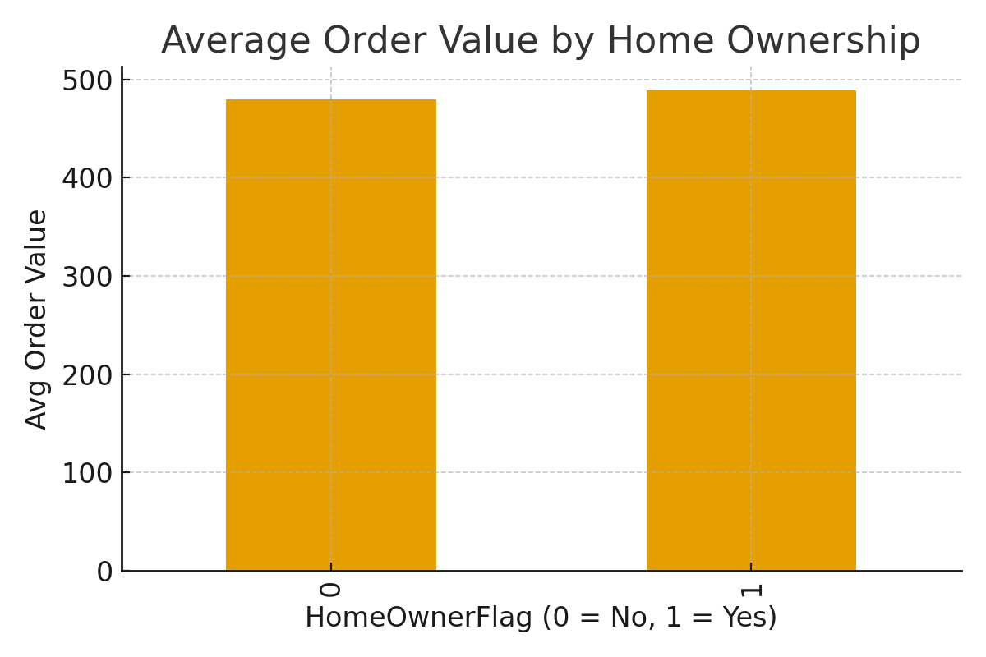

Figure 3. Average Order Value by Home Ownership.

Customer-level perspective (sum of orders per customer), by HomeOwnerFlag:

|  |  |  |  |  |  |  |
| --- | --- | --- | --- | --- | --- | --- |
| HomeOwnerFlag | count | mean | median | min | max | std |
| 0.00 | 5,982.00 | 1,500.05 | 209.96 | 2.29 | 13,265.99 | 2,046.88 |
| 1.00 | 12,502.00 | 1,630.57 | 342.00 | 2.29 | 13,295.38 | 2,159.07 |

# Assumptions & Limitations

• Dataset is fictitious; insights are illustrative only.  
• No explicit Product Category field present; product name used as a proxy.  
• Year derived from OrderDate; malformed dates coerced to missing.  
• Monetary amounts treated as reported without currency conversion.

# Recommendations

# Pay attention to high-end performance bicycles. Products in the mountain series are the most profitable and appeal to wealthy clientele. Maintain your promotion of these via digital platforms and feature enhancements.

# bolster the Australian and American markets. These areas have a high purchasing power and high income levels. Think about regional events or loyalty programs.

# Improve the segmentation of your customer base. Create campaigns that test household-oriented promotions and distinguish between homeowner and non-homeowner demographics.

# Increase the capacity for analytics. To aid in decision-making, create a monthly sales dashboard that tracks region, income, and AOV metrics in real-time.

# Examine the potential for growth in Europe. Moderate price changes or regional promotions could boost penetration even though France and Germany have lower incomes.

# References

* Microsoft Corporation. AdventureWorks sample databases (demo data).
* Course Case Study Template (university‑provided).